AIM: To implement Hierarchical Clustering using Python to group students based on their hours studied and marks, and visualize the clusters using a dendrogram and scatter plot.

ALGORITHM:
1. Start.
2. Import the required libraries.
3. Load the data.csv dataset.
4. Remove extra spaces from column names.
5. Select Hours studied and Marks as features.
6. Create a linkage matrix using the Ward method.
7. Plot the dendrogram.
8. Apply Agglomerative Clustering with 3 clusters.
9. Assign cluster labels to each student.
10. Display the clustered dataset.
11.Plot the clusters using a scatter plot.
12. Stop.

OUTPUT:
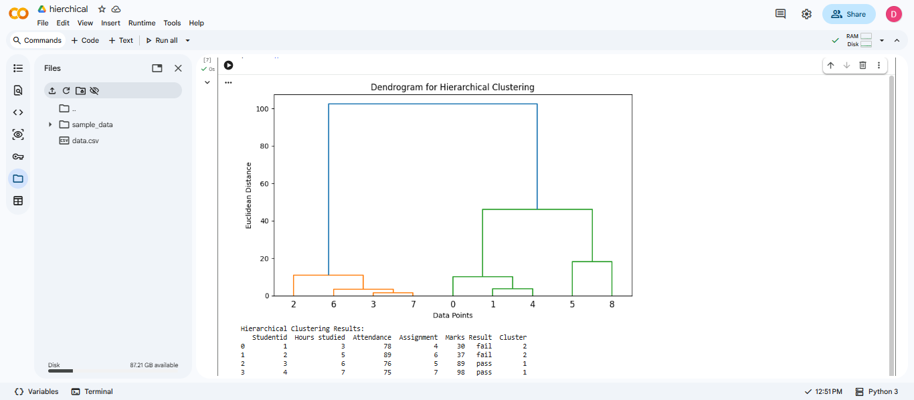

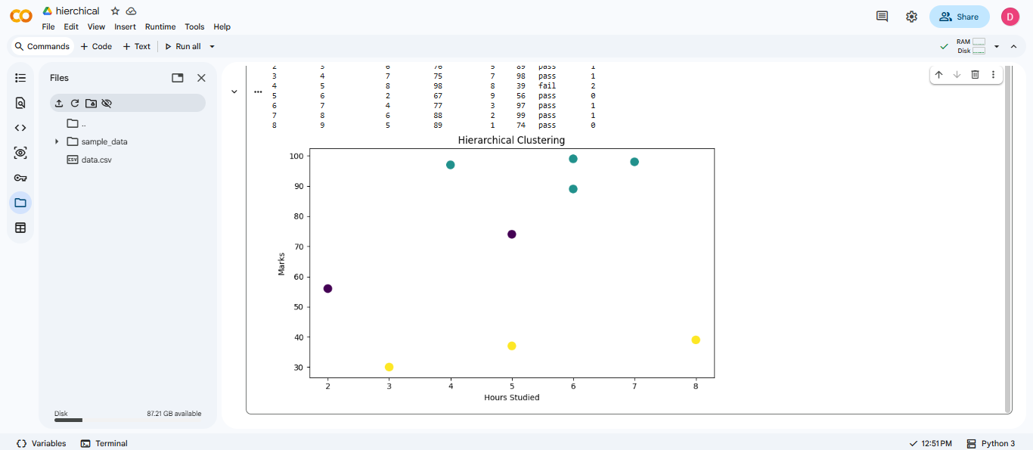

RESULT: Thus, Hierarchical Clustering was successfully implemented using Python to group students based on their hours studied and marks, and the results were visualized using a dendrogram and scatter plot.

